AWS 7

Purpose

In this lab, we are going to explore different database options between SQL or NoSQL. DynamoDB is a fast and flexible NoSQL database service for applications that need consistent low latency at any scale. We are going to create a DynamoDB table assigned with primary and sort keys. We will modify its item attributes and perform scans of the table.

Troubleshoot

Three items successfully created in the DynamoDB. The items have correct attributes and can be searched by both query and scan.

Screenshots

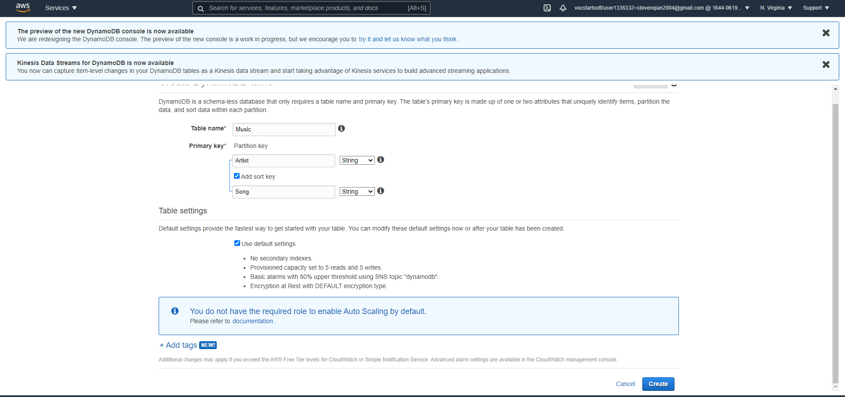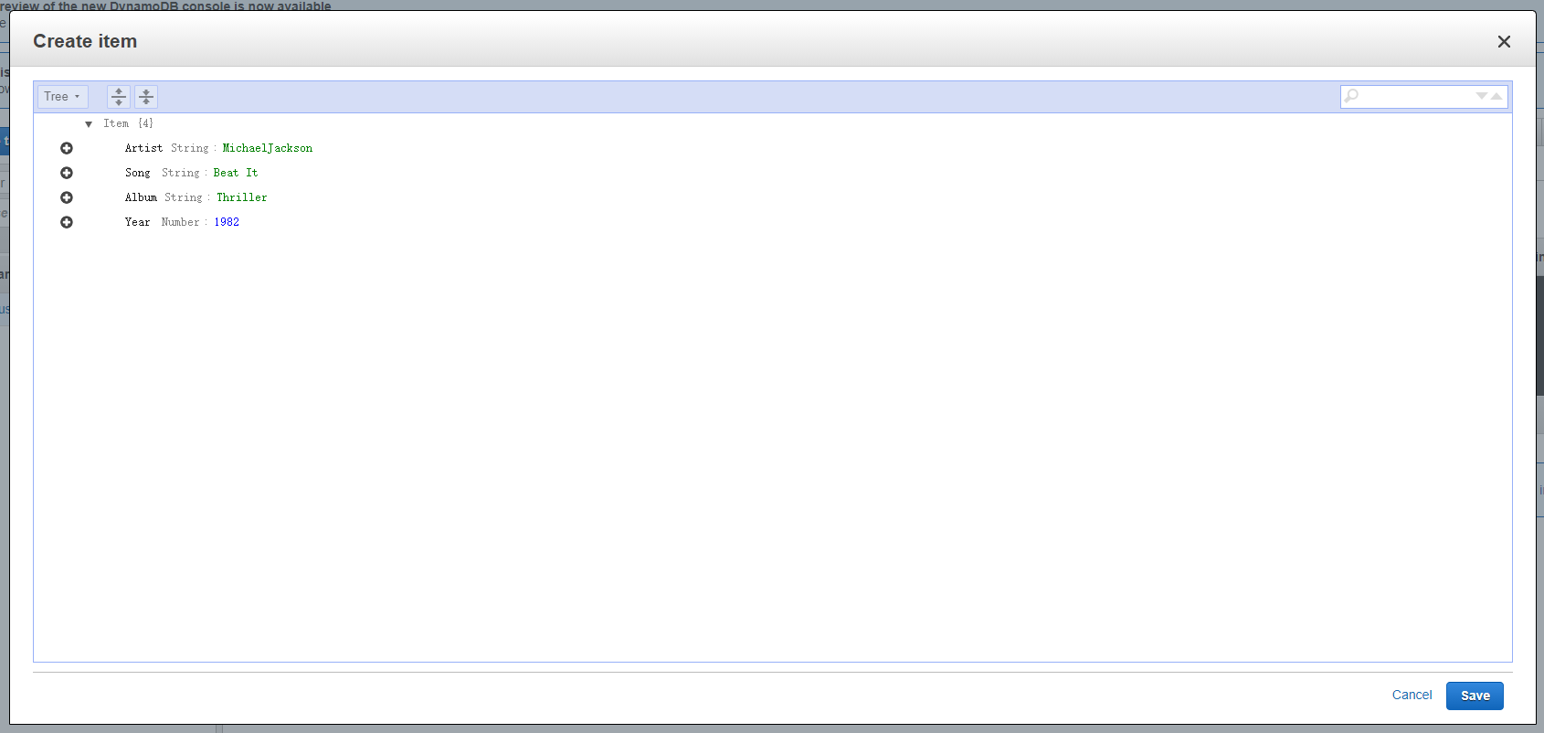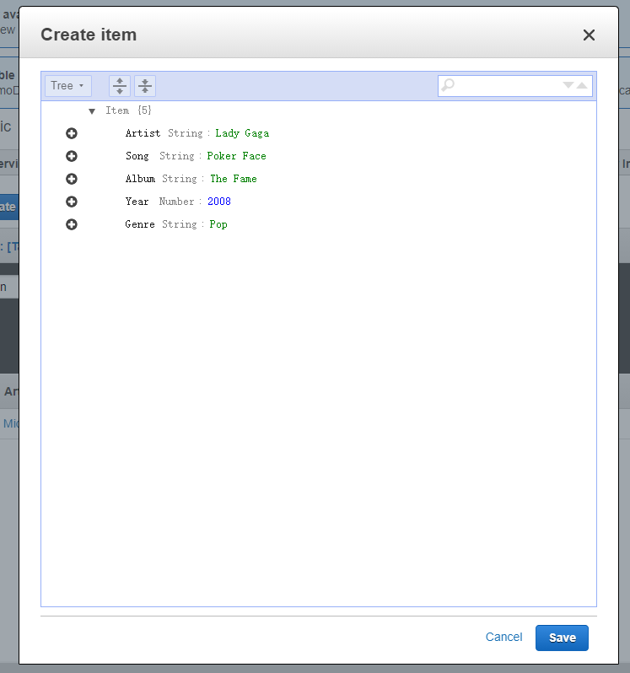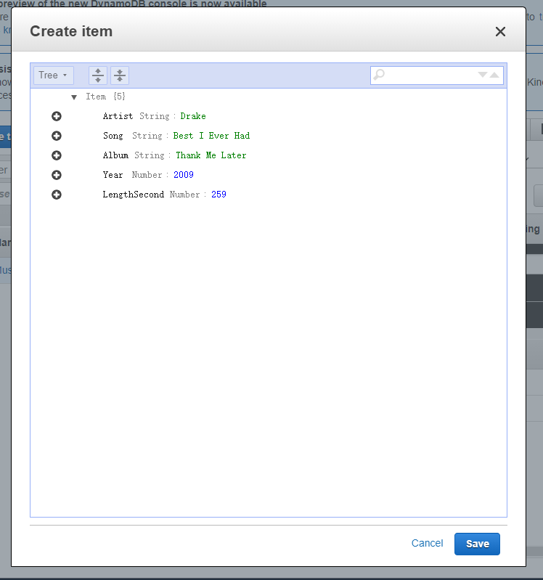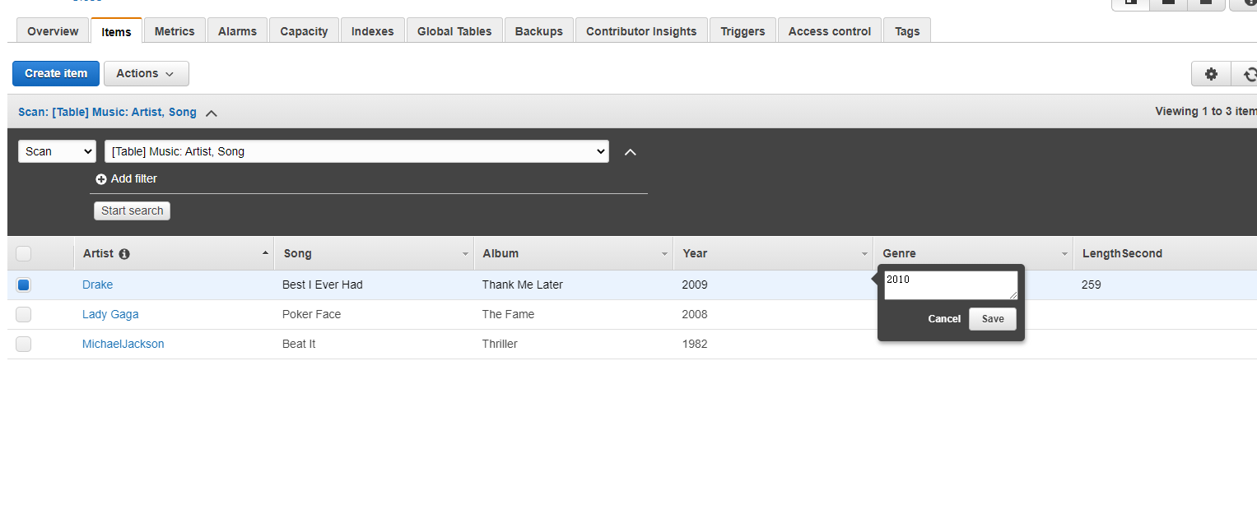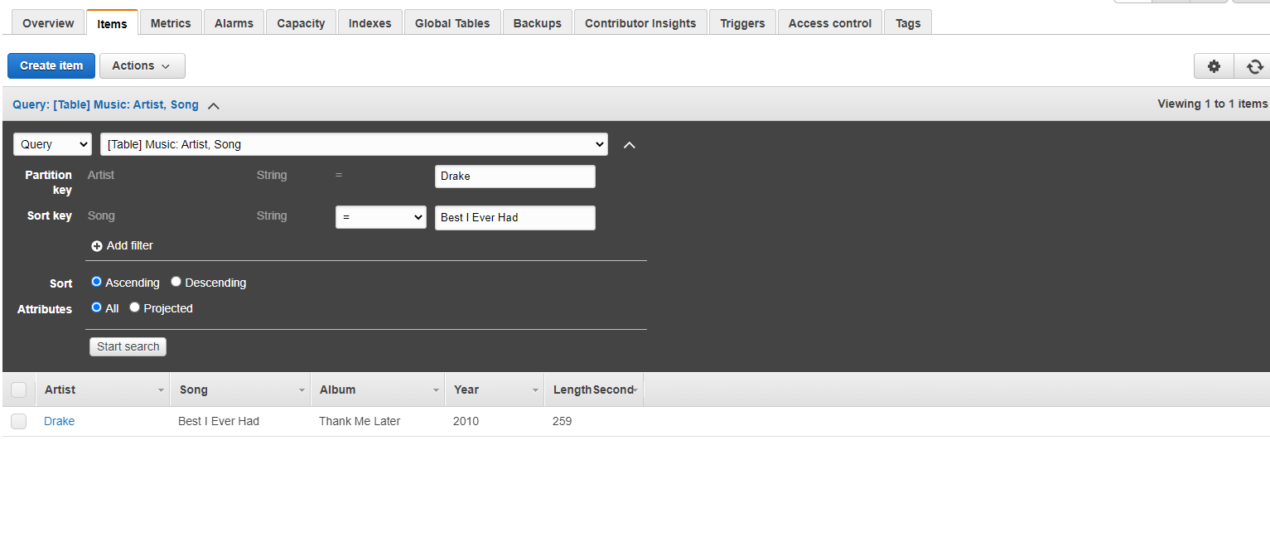

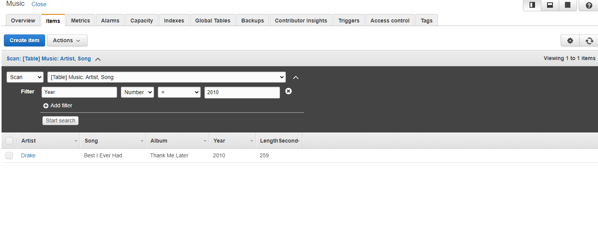

Answers to Questions

* A DynamoDB is a fast and flexible Amazon NoSQL database service for all applications that need consistent, single-digit millisecond latency at any scale. We chose DynamoDB because it can automatically scale up and down to adjust for capacity and maintain performance.
* A Table is a collection of data on a particular topic.
* A primary key and a sort key are a combination of key created when creating an item. They are important because they uniquely identify each item in DynamoDB table.
* An item is a group of attributes that are uniquely identifiable among all the other items.
* An attribute is a fundamental data element.
* N
* String; Binary; Number